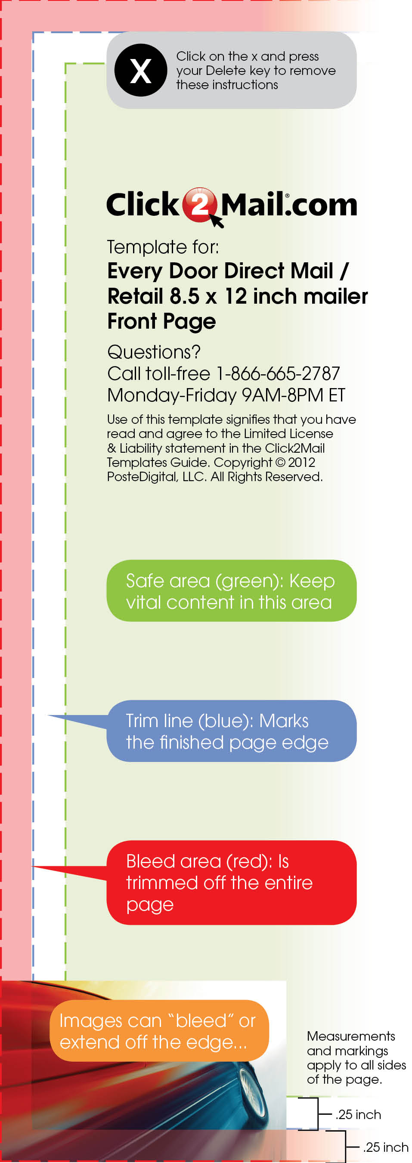
It is time.

Time for your yearly eye exam.

Cornea Eye Care
533 Streetname St.
Yourtown, US 12345

555-123-4567
www.youroptometrist.com



Come see our selection of designer label frames!

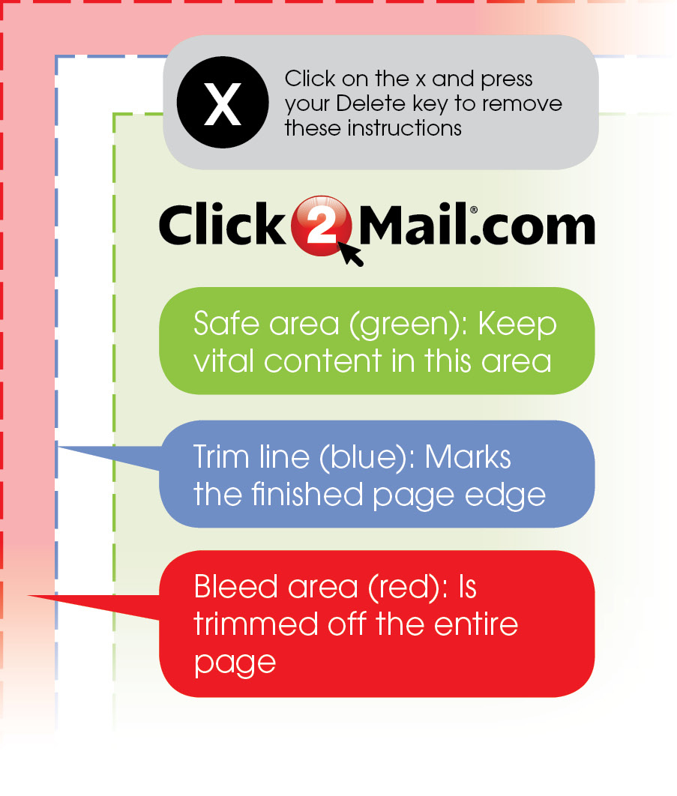

Cornea Eye Care
533 Streetname St. | Yourtown, US 12345
555-123-4567 | www.youroptometrist.com
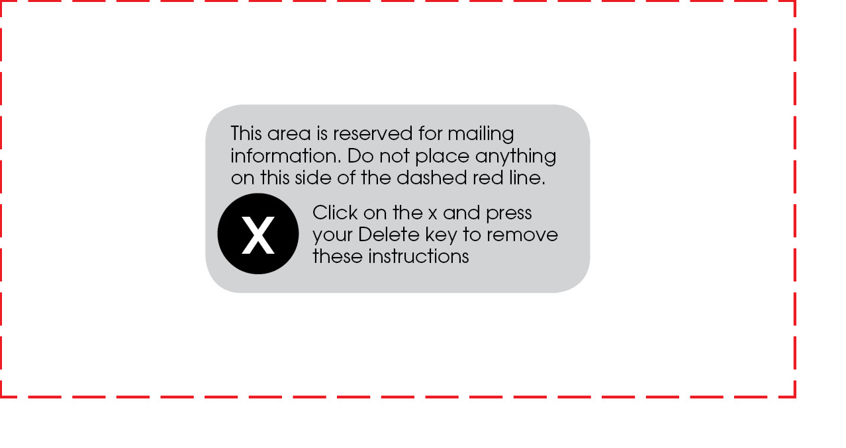
Bring in this card for
%
OFF
30
Complete
Perscription
Eyeware
Must purchase frame & lens.

Not applicable with any vision insurance
coverage or other offers. Outside
prescriptions are accepted.
Offer expires XX/XX/XX.
Most insurances accepted including Medicare.
Sallie Mae Cash, O.D.
Sharon Stone, O.D.
John Q. Public, O.D.
Johnny B. Goode, O.D.

